Mirth Server Installation for RIS

Installation prerequisites
:- JDK 1.6 has to be installed in the server for running the mirth.

Setting System environment

Set a system environment variable “INSTALL4J_JAVA_HOME” with value as path to above above installed jdk1.6 .

For setting this in Linux, edit file /etc/profile , and add the following lines with correct path to jdk1.6 installed.
INSTALL4J_JAVA_HOME=/usr/local/java/jdk1.6.0_11

export INSTALL4J_JAVA_HOME

after adding these settings in /etc/profile, do execute the following command to source the file.

source /etc/profile

Mirth Server configuration.

- Mirth Server ( “MirthConnect_Install.tar.gz”) file inside the “APACS-MWL-BROKER_WITH_MIRTH” resource bundle folder .Copy the file to the server and extract the file. This should create a folder “Mirth Connect” in the extracted path in the server,which will be the Mirth Installation folder.

- Get the following latest HIS jars and copy it in to “Mirth Connect\lib\custom” ( NOTE : This step has to be done only if AHIS library files have been changed due to a any upgrade release in AHIS.)

alis_5.0.jar
emr_5.0.jar
his_5.0.jar
hmoscore_4.3.23.jar
jboss-j2ee.jar
jbossall-client.jar
jcs-1.2.7.77.jar
jdo-1.0.1.jar
jnpserver.jar
jtds-0.5.jar
log4j-snmp-appender.jar
log4j.jar
mm_5.0.jar

- Change the below properties files inside “Mirth Connect\conf”
  - mirth.properties

If any of the below mentioned ports are used by any software already present in this server machine, change these values to new values. Else leave this file untouched.

http.port = 9090
https.port = 18443
jmx.port = 10990

  - his-mirth.properties

Fill the following properties with values corresponding to the HIS server at the site.

AHISInboundProviderURL=<AHIS_SERVER_IP>1099
AHISInboundHisUserLogin=rismwl ( Here enter a valid user name in ahis for JNDI lookup for Service order processing with privilege for processing service order)
AHISInboundHisUserPassword=<Encrypted password for above user>
AHISInboundSiteCode=aims ( Site name )
AHIS_DB_HostName=<AHIS_DB_IP_ADDRESS>
HIS_DB=<AHIS_DB_NAME>
AHIS_DB_User=<AHIS DB USERNAME> - read only privilege
AHIS_DB_Password= <AHIS DB PASSWORD>
PACS_DB_HostName=<PACS DB HOSTNAME /IP>
PACS_DB=<PACS DB NAME>
PACS_DB_User=<PACS DB USER LOGIN NAME> - read only privilege
PACS_DB_Password=<PACS DB USER LOGIN PASSWORD>
Standards_DB_HostName=<AHIS_DB_IP_ADDRESS> - needs a write privilege.
Standards_DB=<AHIS_DB_NAME>
Standards_DB_User=<AHIS DB USERNAME>
Standards_DB_Password= <AHIS DB PASSWORD>
( NOTE : Passwords need to be encrypted ones from HIS database )
APACS_SERVER_IP=<APACS SERVER IPADDRESS>
APACS_LLP_PORT=2575 ( LLP PORT IN APACS HL7Server service )
NAME_FORMAT=false (when set to false, the appended fullname( firstname,middle name and last name) is treated as first name When value is true (for international naming standards ) first name,middle name and last name components are send as first name , middle name and last name itself. Set this value as per the requirement of client)

3) mcserver.sh

You need to set the java 6 path in the mcserver.sh file before starting the mirth.
For this, set the “INSTALL4J_JAVA_HOME_OVERRIDE” variable in the file mcserver.sh to the jdk1.6 path in the system.

Running the Mirth Server

  - Start the Mirth Server. (using following command )
- Go to Mirth Connect folder in Mirth installation folder.
- Type “mcservice” and enter.

  - Import the channels from “Mirth Connect\Mirth RIS channels”.
Channels ( User can skip this step if the Mirth you got already has these channels bundled with it. Check with the concerned person from whom you got this Mirth Server).

For importing mirth channel , take Mirth Client application console by running the following url from browser.

http://<IP_ADDRESS_OF_MIRTH_SERVER>:9090

and from the page that appears, click on “Launch Mirth Connect Administrator” button.
This launches a Mirth Client console window with following options at left top corner of the window.

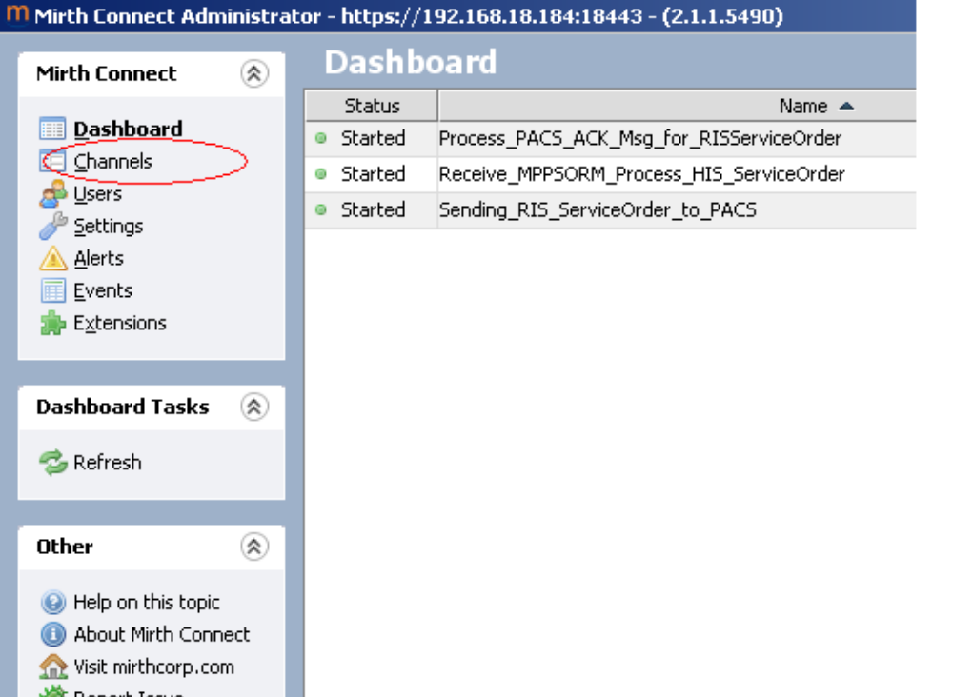

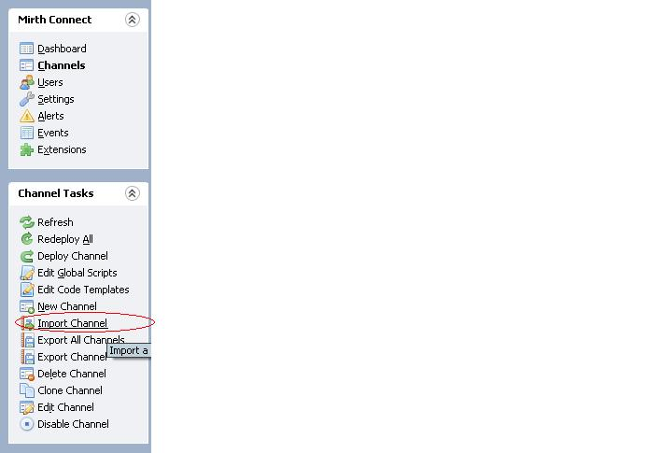

Channels to be imported.

      - Process_PACS_ACK_Msg_for_RISServiceOrder.
      - Receive_MPPSORM_Process_HIS_ServiceOrder.
      - Sending_RIS_ServiceOrder_to_PACS.

  - Deploy these channels using the mirth ( using the “Deploy Channel” button in same window).

Required Ports to be opened for working

Following ports need to be kept open without any firewall blocking .
APACS Server.
104
105
8080
2575
Mirth Server.
6661
9090
AHIS Server.
1099

